Cockshut Around the World

Look at all the places that Cockshut sent farm equipment to! This farm equipment went from Brantford all around the world. Use your map to find each country. If you are using the digital map, make sure to colour and label each country, and save your map when you are done. If you are using the printed map, outline or colour-in the countries. Use the 3 hints to see which hemispheres and continents the country is in.

Digital map: <https://historicalmapchart.net/world-1938.html>

1)

1. This country is in the Southern Hemisphere
2. This country is in the Eastern Hemisphere
3. This country is in Australasia

2)

1. This country is in the Northern Hemisphere
2. This country is in the Western Hemisphere
3. This country is in Europe

3)

1. This country is in the Northern Hemisphere
2. This country is in the Eastern Hemisphere
3. This country is in Asia

4)

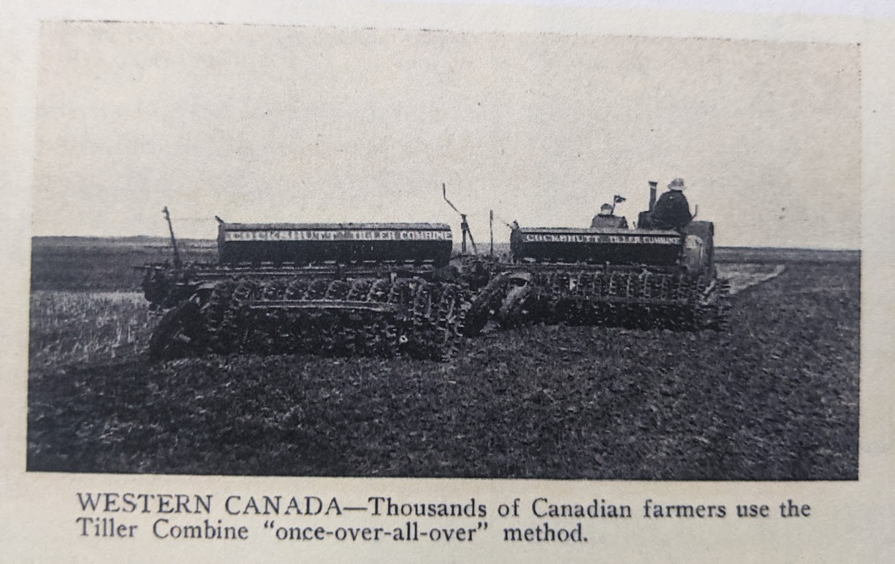

1. This country is in the Northern Hemisphere
2. This country in the Western Hemisphere
3. This country is in North America

5)

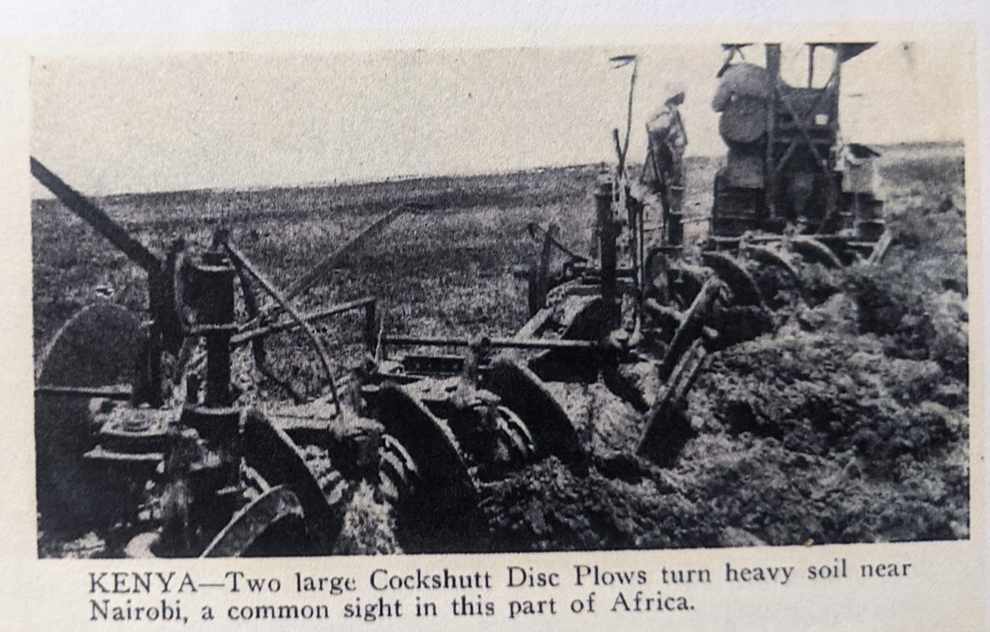

1. The equator runs directly between this country
2. This country is in the Eastern Hemisphere
3. This country is in Africa

6)

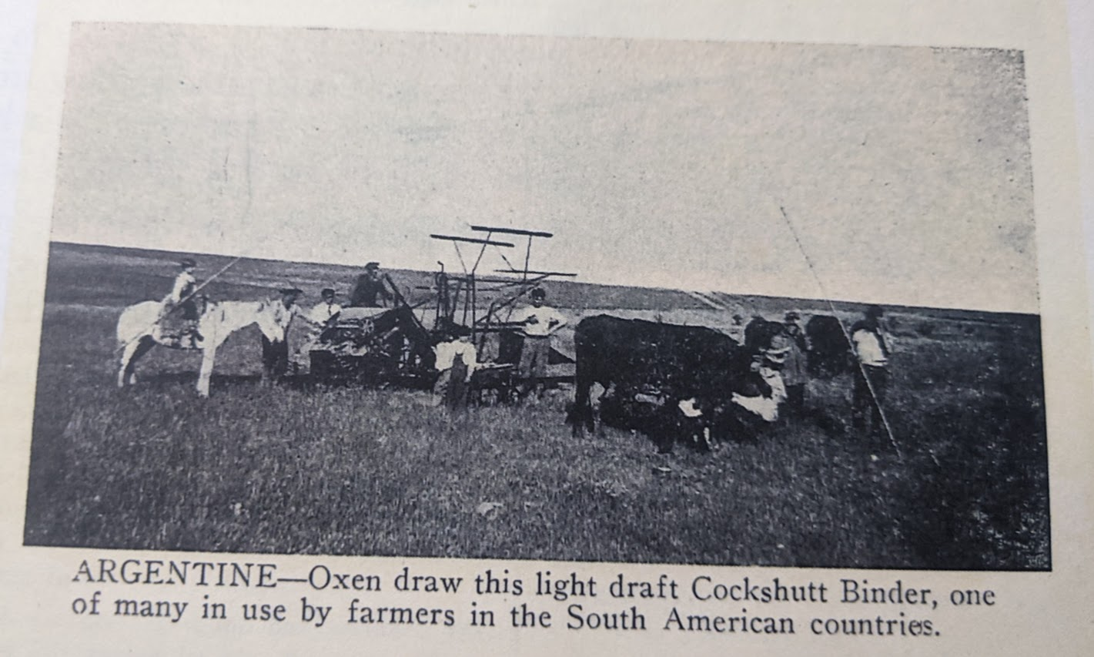

1. This country is in the Southern Hemisphere
2. This country is in the Western Hemisphere
3. This country is in South America

7)

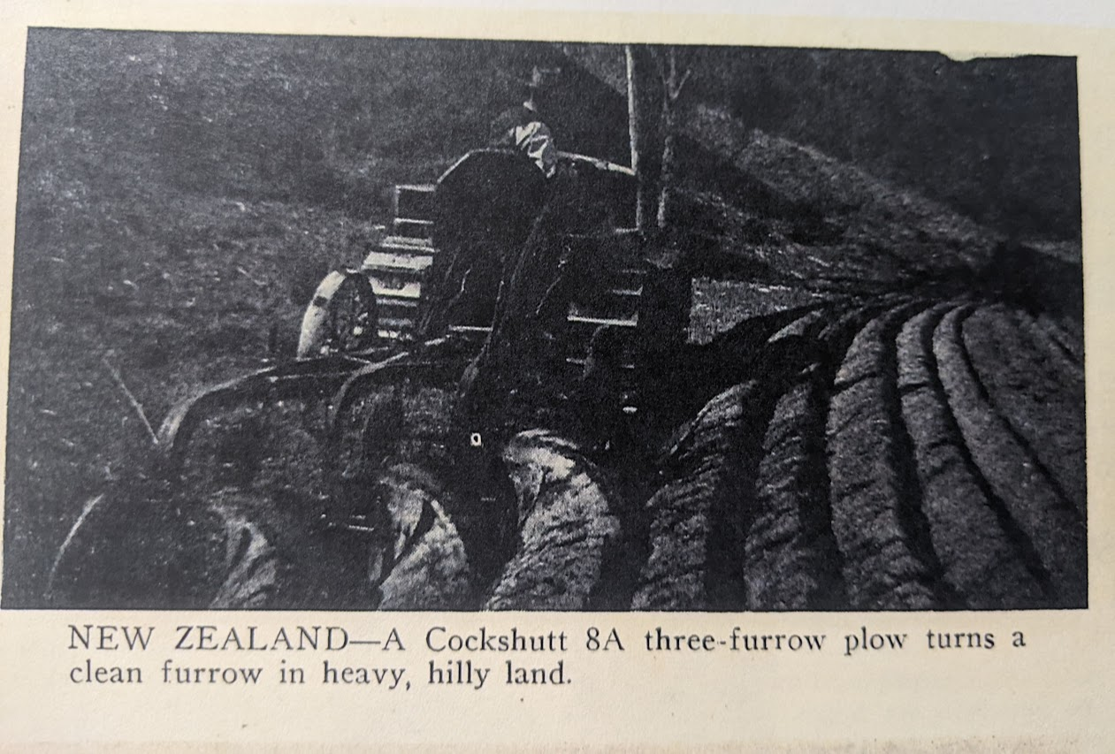

1. This country is in the Southern Hemisphere
2. This country is in the Eastern Hemisphere
3. This country is in Australasia

8)

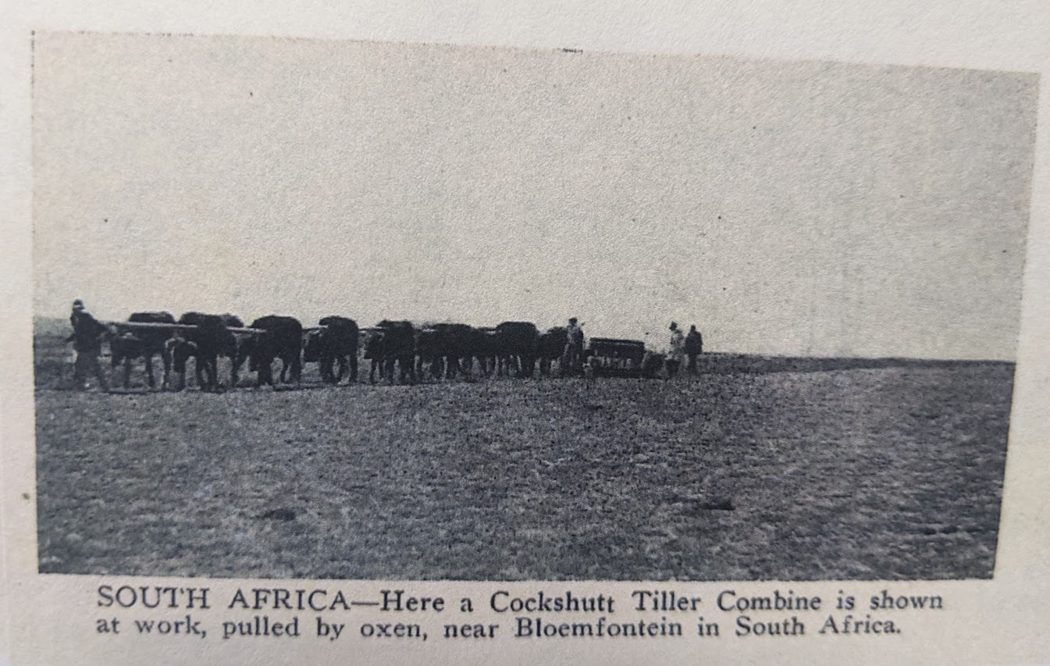

1. This country is in the Southern Hemisphere
2. This country is in the Eastern Hemisphere
3. This country is in Africa

9)

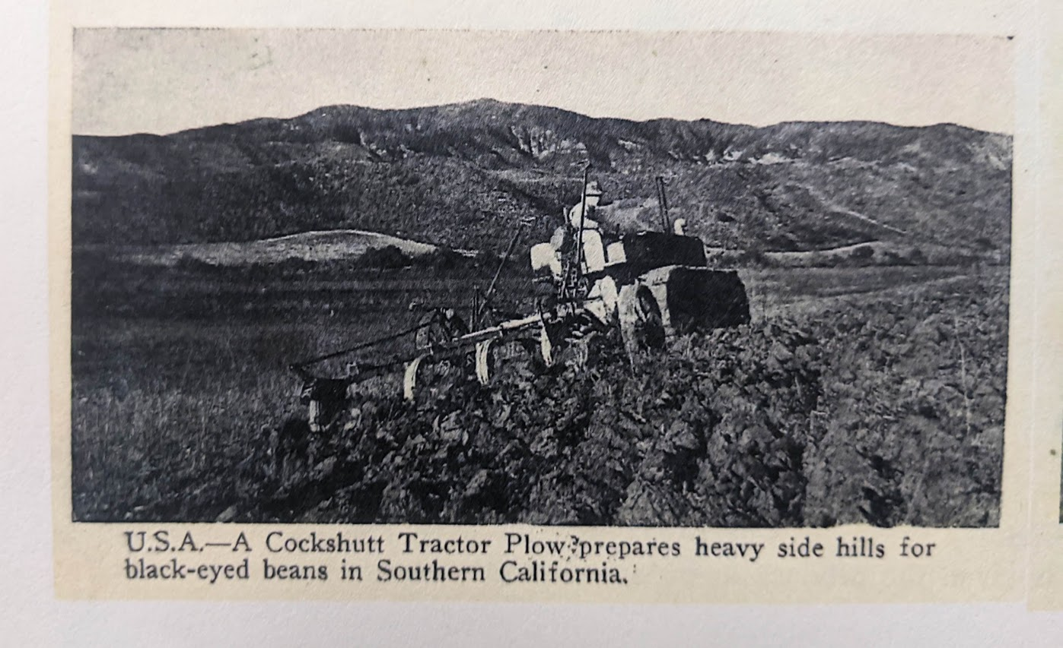

1. This country is in the Northern Hemisphere
2. This country is in the Western Hemisphere
3. This country is in North America

10)

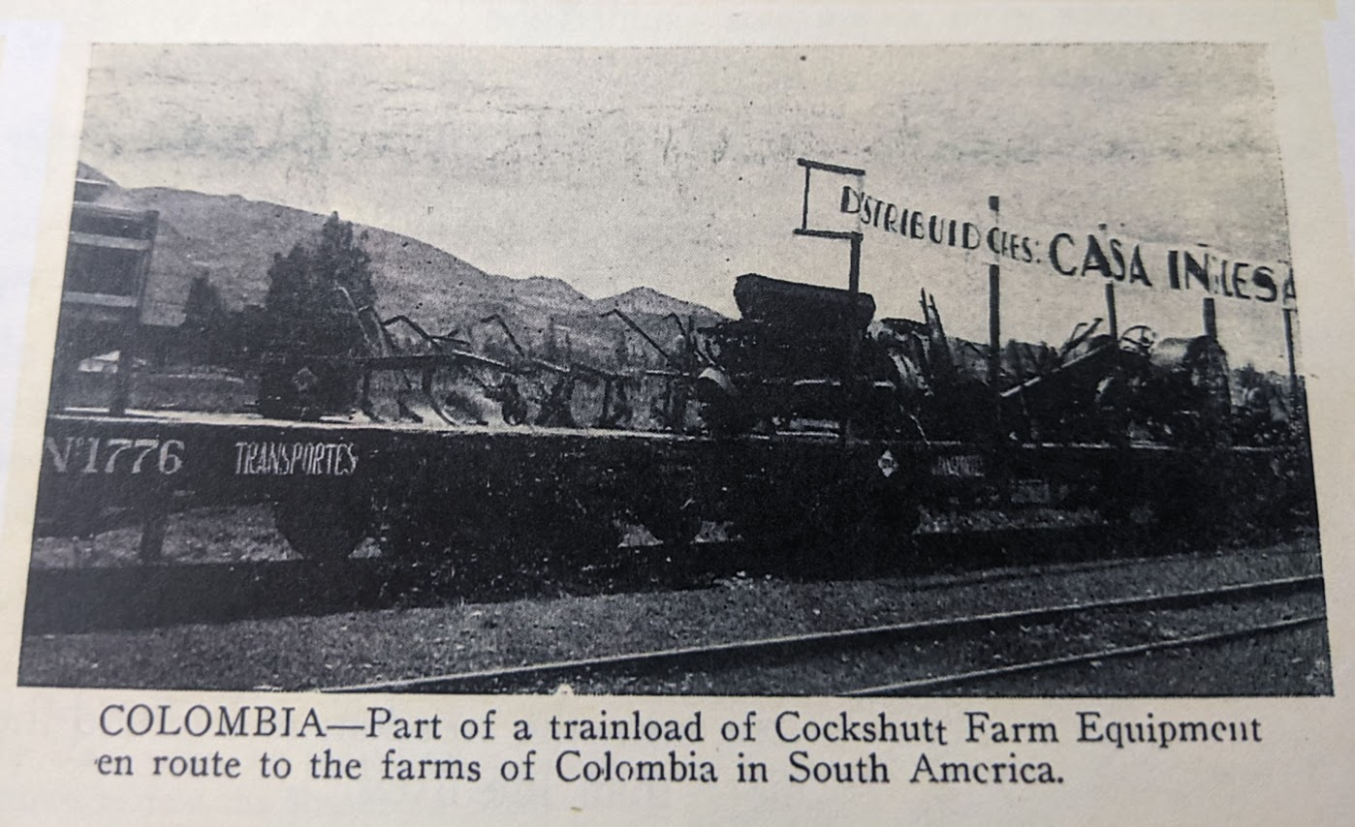

1. This country is mostly in the Northern Hemisphere
2. This country is in the Western Hemisphere
3. This country is in South America

Once you’ve found all your countries go back again and read each of the blurbs under each photo. Think about the slideshow as well. Can you identify any social or environmental issues? What is the importance of international cooperation? Write your thoughts below:

______________________________________________________________________________________________________________________________________________________________________________________________________________________________________________________________________________________________________________________________________________________________________________________________________________________