The Timekeepers Building
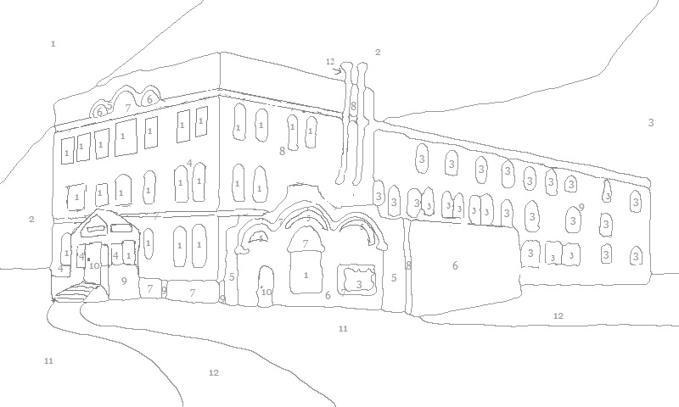

1. Dark Blue 2. Blue 3. Light Blue 4. Maroon 5. Orange
6. Orange 7. Beige 8. Dark Brown 9. Light Brown 10. Pink
11. Green 12. Grey

